Lyman Briggs Lecture Series
Does Intelligence Matter?

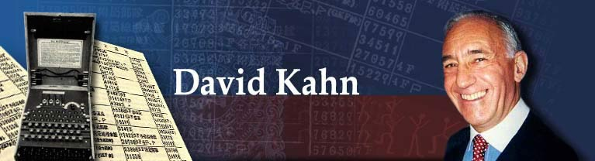

25 October 2006, Wednesday
7:30 p.m.
Wells Hall B 104
of intelligence, particularly of
David Kahn, a historian of intelligence, or code-breaking, is widely regarded as the world’s leading expert on the history of codes and cryptology. His thousand-page The Code-breakers has been called a "classic" and the "standard.” His most recent book is The Reader of Gentlemen’s Mail (Yale, 2006) the life of the colorful, controversial Herbert O. Yardley, who brought the best intelligence – code-breaking -- to America. David Kahn is also the author of Hitler’s Spies, Seizing the Enigma, and Kahn on Codes. He also appears from time to time on the History Channel and elsewhere on television as an expert. He worked for many years as an editor at Newsday, the Long Island daily. He received his Ph.D. in modern history from Oxford University. In addition to his books, David Kahn has written scholarly and popular articles on the subject of codes, cryptology and ciphers in publications ranging from The New York Times to Playboy, from the Journal of Strategic Studies to the Encyclopedia Americana. Kahn has taught courses on modern political and military intelligence at Yale and Columbia and has testified before Congress on policy matters dealing with cryptology.

Sponsored by Lyman Briggs and History in cooperation with the College of Natural Science, the College of Social Science, the Provost’s Office, James Madison College, School of Criminal Justice, and the Departments of Mathematics, Computer Science. Michigan State University.

